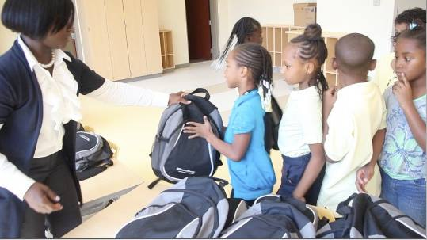
The Backpack Project, Inc.
FACT SHEET
The Backpack Project, Inc. (Our Mission) is a non-profit organization devoted to addressing the educational supply needs of under-resourced children, specifically, living in the Ward 8 community. We do this by providing new backpacks, school supplies, school uniforms, and mentoring programs. We have been in existence since 2009 and have provided support to over 3,000 children and families.
Our mission is simple – One Child, One Mentor, One Backpack at a Time; but profound, and its impact on the life of a child is immeasurable.
The Backpack Project, Inc. evolved out of an idea of one person wanting to make a difference in a community that was lacking in resources and support.
With a population of 70,068, which includes 8,220 of kids ages 5-20 (www.suburbanstats.org), Ward 8 is one of the poorest wards in Washington, DC, citing an unemployment rate of 11.6 percent – just in Ward 8, compared to 11.8 percent for the entire Washington, DC area. The students we service are from Title 1 schools (majority of its students receive free or reduced lunch, because of their poverty level status.)
We believe that every child, regardless of their economic or social status, should be fully prepared and ready to learn on the first day of school and are committed to making this happen. We also believe in the importance of reading and writing outside of the classroom setting. For this reason, every backpack includes a reading book and writing journal and all of our mentoring programming incorporates a reading and writing component.
One of the most effective means of ending generational cycles of poverty is a quality basic education. It does more than simply equip children with the knowledge and skills necessary to take an active role in their lives, it creates a cycle of opportunity and tips the scale in their favor for continued life success.
Unfortunately, many families in this area are unable to provide the very basic school necessities for their children. As a result, many students start school unprepared and detached from learning. This behavior aids to the decrease in high school graduation and advanced education completion rates. This is where our organization is making a difference.
How We Have Made A Difference So Far:
- Have donated over 3,000 new backpacks with school supplies and school uniforms to needy students;
- Have provided mentoring services to over 100 children in grades 4th – 7th;
- Are one of the only non-profit organizations serving the Ward 8 community with wrap-around services which include: year-long backpack distributions; school uniform assistance; and a yearlong mentoring program (October – June; and summer camp in August);
- Are one of the only non-profits in the nation’s capital where 98% of its donations go directly to its programming;
- But, we are more than just backpacks. We have provided additional services to needy families, in the areas of: monthly food donations – to date, have donated over 200 food baskets; holiday gifts & toys drives – to date, have donated over 650 gifts and household goods; and annual coat drives – to date, have donated over 200 coats.
In the coming year, The Backpack Project, Inc. plans to continue its programming services of providing new backpacks and mentoring programs, Backpack Buddies, to the Ward 8 community. We believe a continuation of these services will aid these students in increased test scores in reading and math, a successful educational transition from elementary to college, produce a reduction in crime rates for this population, provide support in a wrap-around approach, addressing several areas of family need for these students, and create opportunities for these students to experience positive life experiences outside of their neighborhood environments.

